PROJECT PROPOSAL


KENYATTA UNIVERSITY
SCHOOL OF PURE AND APPLIED SCIENCES
COMPUTING & INFORMATION SCIENCE DEPARTMENT
SCO400 PROJECT: CHAPTER FOUR & FIVE

STUDY CUE: AI-POWERED STUDY ASSISTANT FOR PERSONALIZED LEARNING

Project Supervisor: Dr. Benard Ondara
Student: Brian Rotich J17/0990/2022

This project proposal is submitted for the partial fulfillment of the requirements for the award of the degree of Bachelor of Science in Computer Science in the School of Pure and Applied Sciences of Kenyatta University.
CHAPTER FOUR: SYSTEM ANALYSIS AND REQUIREMENT MODELING

4.1 Introduction
This chapter provides a detailed analysis of Study Cue, an AI study assistant designed to personalize the learning experience for students. The analysis examines the current challenges students face with traditional study methods, formalizes the requirements for an intelligent digital solution, and evaluates the feasibility of the proposed system. Through fact-finding techniques including surveys, interviews, and document analysis, the researcher established the necessity for a platform that integrates automated study planning, resource curation, and interactive document analysis.

The following sections will detail the organizational framework of the Study Cue platform, an analysis of the existing manual study methods, and the functional specifications of the proposed AI-driven system. This analysis serves as the foundation for the subsequent system design and implementation phases, ensuring that the solution addresses the core comprehension and time-management gaps identified during the research process.

4.2 Structure of the Organisation
Study Cue operates as a personalized learning ecosystem involving several key stakeholder groups. The system is designed to provide autonomy to the learner while leveraging advanced AI services for support.
- System Administrator: Responsible for maintaining the technical infrastructure, managing API integrations (Groq, Tavily, HuggingFace), monitoring system performance, and ensuring data security and platform integrity.
- Student (User): The primary beneficiary of the platform. Students interact with the AI to generate study plans, upload PDF documents for interactive chat, discover curated resources, and manage their academic notes and progress.
- AI Service Providers (External): Groq provides high-speed inference for natural language tasks; Tavily facilitates intelligent web searching for resources; HuggingFace provides embedding models for semantic document analysis.
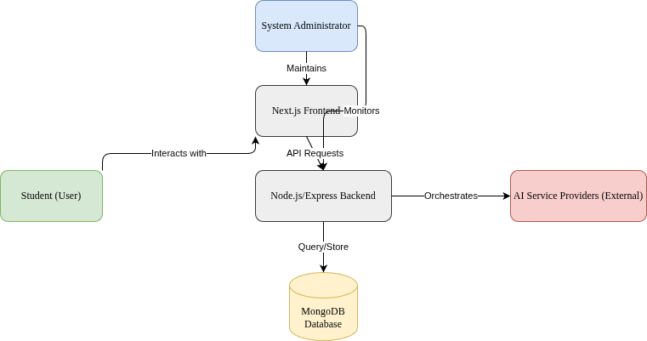
Figure 4.1: The Organizational Structure of the Study Cue platform, showing interactions between users, the technical stack, and external AI services.

4.3.1 Current System Analysis
Before detailing the requirements of the proposed system, it is essential to visualize the flow of data within the current manual study process. The following diagram illustrates the fragmented nature of resource discovery and schedule management.
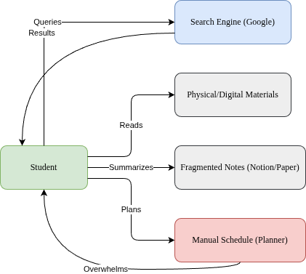
Figure 4.2: Data flow within the current manual study process, highlighting the fragmented nature of resource discovery and planning.

4.3.1 Problems of the Current System
- Inefficient Time Management: Manual planning fails to account for topic complexity or optimal spacing effects, leading to burnout or inadequate preparation.
- Information Overload: Students struggle to filter high-quality academic resources from the vast amount of irrelevant information online.
- Comprehension Gaps: Dense academic PDFs are often difficult to understand without immediate support, leading to frustration and stalled progress.
- Cognitive Overhead: Switching between multiple unrelated tools for planning, note-taking, and resource discovery reduces focus and productivity.
- Lack of Personalization: Generic study tools do not adapt to the specific subjects, deadlines, or learning styles of individual students.

4.4 Fact Finding Report
The researcher employed multiple fact-finding techniques to gather requirements and validate the problems identified.

4.4.1 Method 1: Observation
Observation of students in academic environments (libraries, study halls) revealed that many spend up to 30% of their "study time" simply organizing materials or searching for resources rather than actually learning. There is a clear need for a centralized system that automates these administrative tasks of study planning and resource curation.

4.4.2 Method 2: Questionnaire/Surveys
Online questionnaire ( https://forms.gle/K58NqMEKirnFzSsPA ) distributed to undergraduate students at Kenyatta University indicated:
- 85% of students find it difficult to find quality resources for specific technical topics.
- 70% struggle with maintaining a consistent study schedule.
- 90% expressed strong interest in an AI tool that could "explain" their PDF textbooks.

4.4.3 Method 3: Document Analysis
Analysis of existing educational tech platforms like Khan Academy and Quizlet showed a gap in providing personalized, document-specific AI assistance. While generic AI bots exist, they are rarely integrated into a comprehensive study workflow that includes planning and resource curation.

4.5 Feasibility Study

4.5.1 Economic Feasibility
Study Cue is economically viable. By utilizing open-source frameworks (Next.js, Express) and cost-effective AI APIs (Groq), the development and operational costs are kept low. The primary expenses are API credits and cloud hosting, which are scalable based on user growth.

4.5.2 Technical Feasibility
The proposed stack (Next.js 14, Node.js, MongoDB) is robust and well-documented. Integration with Groq and HuggingFace is technically achievable using standard REST APIs and specialized libraries like PDF.js. The researcher possesses the necessary skills in TypeScript and JavaScript to implement these features.

4.5.3 Operational Feasibility
The system uses modern web UI patterns familiar to students, ensuring a low learning curve. Operationally, it simplifies the student's workflow by consolidating multiple study tools into one intelligent interface, making it highly likely to be adopted.

4.6 The Proposed System
Study Cue will provide an integrated, AI-driven environment for academic success through automated study planning, resource curation, and interactive document analysis.

4.6.1 Requirements Specifications
a. User Requirements:
- Generate customized study plans by inputting subjects and exam dates.
- Upload and chat with PDF documents to get instant explanations.
- Receive curated external resources (videos, articles) tailored to study topics.
- Manage notes and track study time using a Pomodoro timer.

b. Functional Requirements:
- AI Study Plan Engine: Automated generation of weekly/daily schedules.
- PDF RAG (Retrieval-Augmented Generation): Semantic search and chat within documents.
- Intelligent Resource Discovery: Topic-based search using Tavily API.
- Analytics Dashboard: Visualizing study hours and progress.
c. Non-Functional Requirements:
- Performance: AI responses and PDF processing in < 5 seconds.
- Security: Secure authentication via NextAuth.js and data encryption.
- Responsiveness: Mobile-first design for studying on any device.
- Reliability: 99.9% uptime for the API and database.

4.7 Data Flow Diagrams
The modeling of the proposed system is detailed through various levels of Data Flow Diagrams (DFDs) and a Use Case diagram to illustrate the interactions between the user and the system components.

4.7.1 Proposed System Context Diagram (Level 0 DFD)
The Context Diagram defines the scope of Study Cue, showing the high-level boundaries between the system and its external entities.
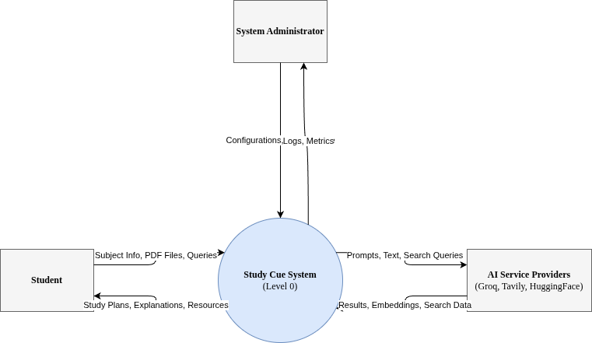
Figure 4.3: Proposed System Context Diagram (Level 0 DFD) defining the system boundaries and external entities.

4.7.2 Proposed System Logical DFD (Level 1)
The Level 1 DFD breaks down the system into its primary processes, illustrating how data flows between study planning, document analysis, and resource curation.
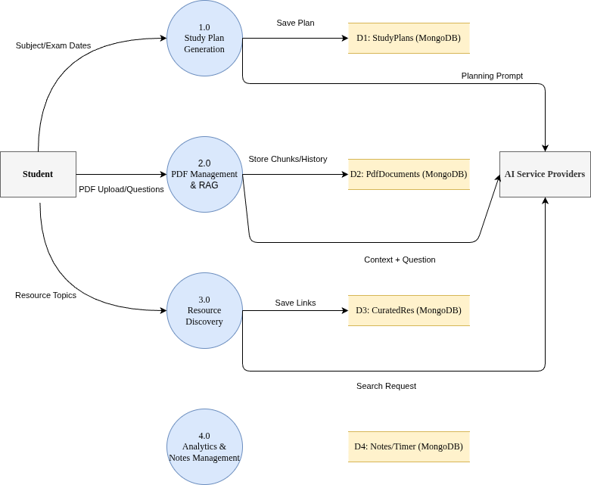
Figure 4.4: Proposed System Logical DFD (Level 1) illustrating the internal functional modules and data movement.

4.7.3 Proposed System Use Case Diagram
The Use Case Diagram highlights the core interactions available to the student within the Study Cue ecosystem.
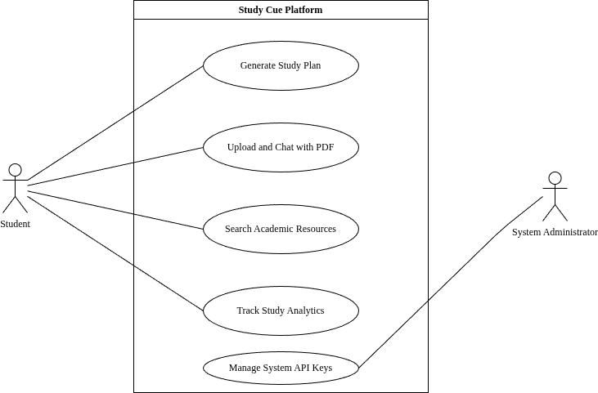
Figure 4.5: Proposed System Use Case Diagram detailing the core functionalities available to the Student and Administrator.

CHAPTER FIVE: SYSTEM DESIGN

5.1 Introduction
This chapter details the technical design of Study Cue, transforming the requirements into a functional architecture. It covers the system architecture, process modeling, database design, and user interface layouts.

5.2 Architecture of the Proposed System
Study Cue follows a modern Full-Stack Decoupled Architecture, splitting concerns between a reactive frontend and a logic-heavy backend.
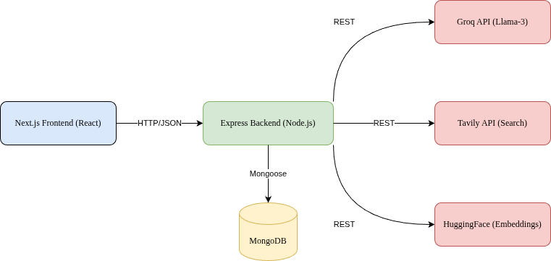
Figure 5.1: Proposed System Architecture Diagram showing the decoupled full-stack infrastructure and integration with AI APIs.

The system components are as follows:
- Frontend (Next.js 14): A responsive web application using React Server Components for performance and Shadcn UI for a premium aesthetic.
- Backend (Node.js/Express): A RESTful API that orchestrates logic between the database and external AI services.
- Database (MongoDB): A NoSQL database for flexible storage of study plans, chat histories, and notes.
- AI Services:
  - Groq: LLM inference (Llama-3) for text generation and reasoning.
  - HuggingFace: Sentence embeddings for PDF search.
  - Tavily: Academic-focused web search.

5.3 System Process Modeling
The following sequence diagrams illustrate the core workflows of the Study Cue platform, specifically the AI-driven study planning and the Retrieval-Augmented Generation (RAG) process for document chat.

5.3.1 User Registration and Authentication Process
The authentication system leverages NextAuth.js to provide secure access via OAuth (Google) and Credentials-based protocols, ensuring user data privacy and session persistence.

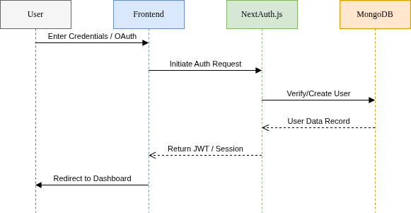
Figure 5.2: Sequence Diagram illustrating the secure user registration and authentication flow.

5.3.2 Study Plan Generation Process
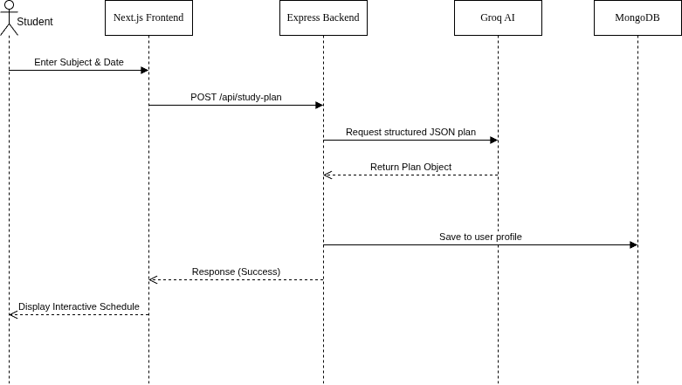
Figure 5.2: Sequence Diagram illustrating the AI-driven study plan generation workflow.

5.3.3 PDF Chat (RAG) Process
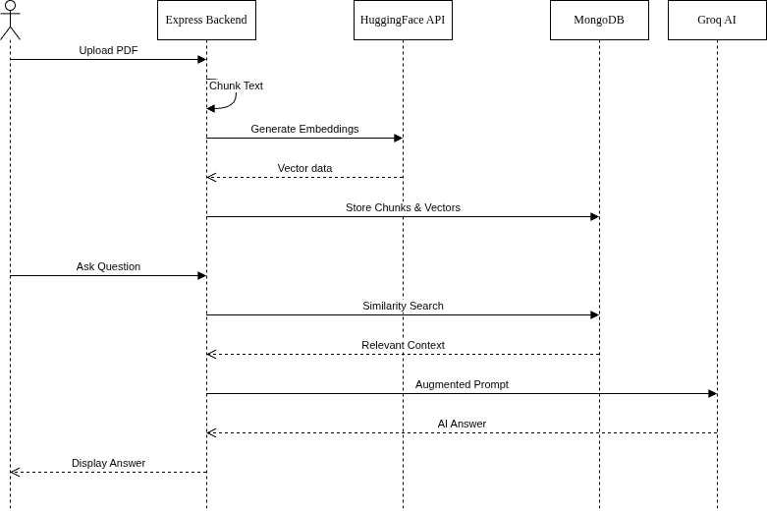
Figure 5.3: Sequence Diagram illustrating the Retrieval-Augmented Generation (RAG) process for interactive PDF chat.

5.3.4 Resource Search and Curation Process
Study Cue automates the discovery of academic materials by integrating real-time web search with AI summarization.
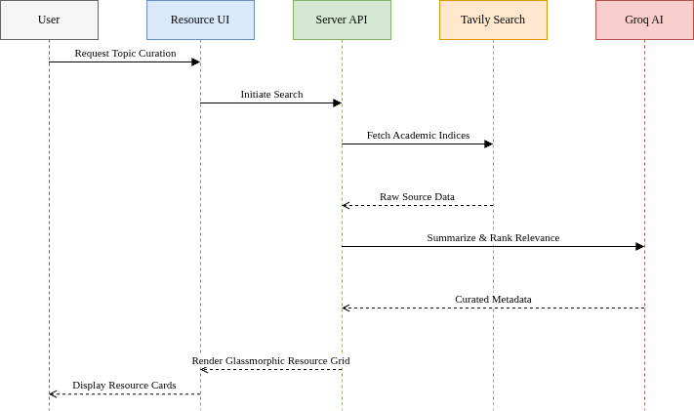
Figure 5.5: Sequence Diagram illustrating the automated resource discovery and curation workflow.

5.3.5 Notes Creation and Management Process
The platform allows users to capture insights from AI chats or manual study sessions into a centralized "Neural Library" where the user can edit or modify the notes.
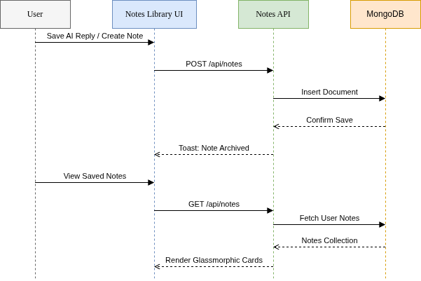
Figure 5.6: Sequence Diagram illustrating the note creation, archival, and retrieval process.

5.4 Database Design
The database uses MongoDB collections to handle relational and semi-structured data.

5.4.1 Data Dictionary (Core Collections)
Collection: Users
Field | Data Type | Constraint | Description
_id | ObjectId | Primary Key | Unique user identifier
name | String | Required | Full name of the user
email | String | Required, Unique | Login identifier
password | String | Required | Hashed credentials
subjects | Array | Optional | List of academic interests
savedPlans | Array | Embedded | List of generated study plans
savedResources | Array | Embedded | Curated materials saved by user
stats | ObjectId | Foreign Key | Reference to StudyStats
Collection: StudyPlans
Field | Data Type | Constraint | Description
_id | ObjectId | Primary Key | Unique plan identifier
userId | ObjectId | Foreign Key | Owner of the plan
overview | Object | Required | Subject, duration, and exam date
weeklyPlans | Array | Required | Temporal schedule with tasks
isActive | Boolean | Default: True | Current monitoring status
progress | Number | 0-100 | Completion percentage
lastUpdated | Date | Default: Now | Last activity timestamp
Collection: Notes
Field | Data Type | Constraint | Description
_id | ObjectId | Primary Key | Unique note identifier
userId | ObjectId | Foreign Key | Author of the note
title | String | Required | Display title
content | Array | Blocks | JSON-based block structure
path | String | Default: '/' | Hierarchy placement
isArchived | Boolean | Default: False | For soft deletion
Collection: StudyStats
Field | Data Type | Constraint | Description
_id | ObjectId | Primary Key | Unique stats identifier
userId | ObjectId | Foreign Key | User performance link
totalHours | Number | Accumulated | Total time in Focus mode
currentStreak | Number | Daily | Consecutive study days
dailySessions | Map | Complex | Log of Pomodoro completions
Collection: PdfDocuments
Field | Data Type | Constraint | Description
_id | ObjectId | Primary Key | Unique document identifier
userId | ObjectId | Foreign Key | Owner of the document
title | String | Required | Filename for display
chunks | Array | Required | Text segments for RAG context
embeddings | Array | Required | Vector data for semantic search
chatHistory | Array | Optional | List of previous Q&A pairs
Collection: CuratedResources
Field | Data Type | Constraint | Description
_id | ObjectId | Primary Key | Unique resource set identifier
userId | String | Required | User who requested search
topic | String | Required | The search keyword/topic
resources | Array | Required | URLs, types, and AI summaries
lastUpdated | Date | Default: Now | Freshness timestamp

5.5 User Interface (UI) Design
The UI is designed to be "Calm and Focused," leveraging a glassmorphic aesthetic to minimize cognitive load while maintaining a premium, high-tech feel. All interfaces prioritize dark modes with vibrant neon accents to guide user attention.

5.5.1 Dashboard Interface
The central hub for student activity, the Dashboard integrates temporal tracking with real-time progress monitoring.
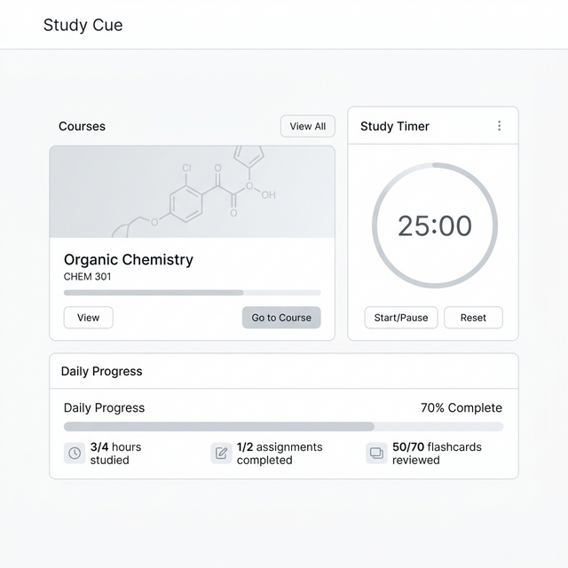
Figure 5.8: The Study Cue Dashboard providing a summary of active courses, progress tracking via the "Neural Roadmap" chart, and an integrated Pomodoro timer for focused study sessions.

5.5.2 PDF Workshop (Interactive Reading)
The PDF Workshop is the core interaction layer where theoretical material meets AI reasoning.
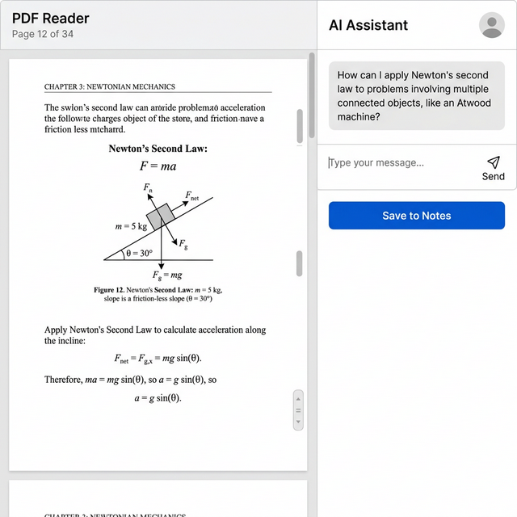
Figure 5.9: The PDF Workshop featuring a split-screen design for simultaneous reading and AI-assisted analysis. The interface includes an AI Study Assistant with the ability to archive insights directly to notes.

5.5.3 Resource Library (Discovery Engine)
The Resource Library uses AI to curate and summarize external academic materials.
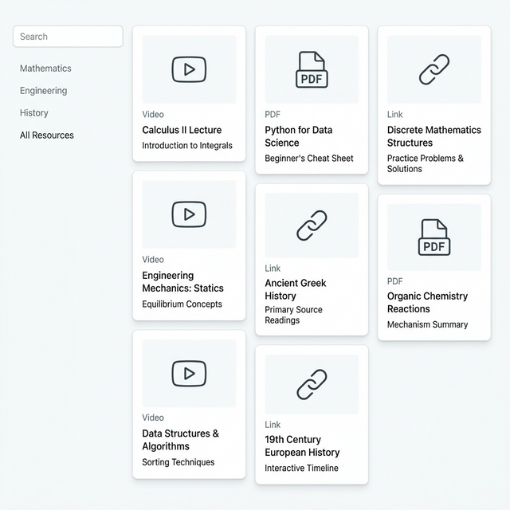
Figure 5.10: The Resource Library presenting a curated masonry grid of materials enhanced with AI-generated "Neural Summaries" for rapid relevance evaluation.

5.5.4 Study Plan (Neural Roadmap)
The Study Plan utilizes temporal mapping to visualize a student's journey toward exam readiness.

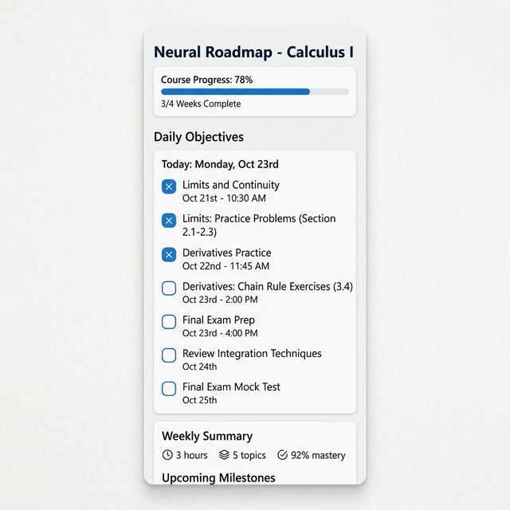
Figure 5.11: The Neural Roadmap interface providing a timeline visualization of study milestones, daily focus tasks, and streak tracking.

5.5.5 Study Notes Library (Notes Management)
The Neural Library serves as the long-term knowledge repository for captured insights.

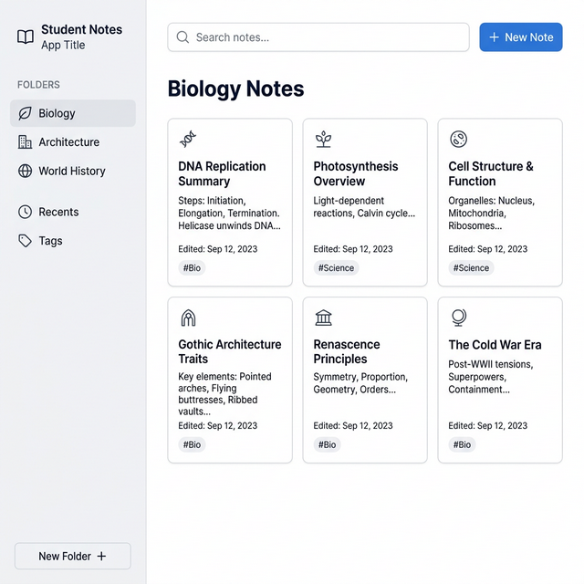
Figure 5.12: The Study Notes Library interface featuring card-based notes management with hierarchical folder structures and semantic tagging.

